DIABETES PREDICTION PROJECT
Submitted for
Exploration & Seminars in AI ABAI1009P
Submitted by:
Prashansa Gupta A25ARIU0069
Nehal Babel A25ARIU0051
Shreya kashyap A25ARIU0060

Submitted to
DR. SHAKSHI SHARMA
July–Dec 2025
SCHOOL OF ARTIFICIAL INTELLIGENCE

INDEX
Sr. No | Content | Page No
1 | Abstract
2 | Introduction
3 | Related Work
4 | Methodology
5 | Hardware/Software Required
6 | Experimental Results
7 | Conclusions
8 | Future Scope
9 | GitHub Link

Abstract
This project aims to predict the likelihood of diabetes using machine learning techniques. By analyzing medical attributes such as glucose level, BMI, age, and more, the model provides a quick prediction that may help users take preventive healthcare measures.

Introduction
Diabetes is one of the most common chronic diseases globally. Early detection helps prevent complications and encourages lifestyle modifications. This project provides a web-based interface that allows users to input basic medical details and receive instant predictions using a trained machine learning model.

Related Work
Previous studies have explored machine learning algorithms such as Logistic Regression, Random Forest, and SVM for diabetes prediction. Many research papers use the PIMA Indian Diabetes Dataset, which also forms the basis of this project.

Methodology
1. Data Collection: PIMA Diabetes Dataset
2. Data Preprocessing: Handling missing values, normalization
3. Model Selection: Classification model (e.g., Logistic Regression)
4. Model Training & Evaluation
5. Building the web interface using Streamlit

Hardware/Software Required
- Python 3
- Libraries: NumPy, Pandas, Scikit-learn, Streamlit
- System Requirements: Basic laptop/PC

Experimental Results
Below are screenshots of the prediction interface:
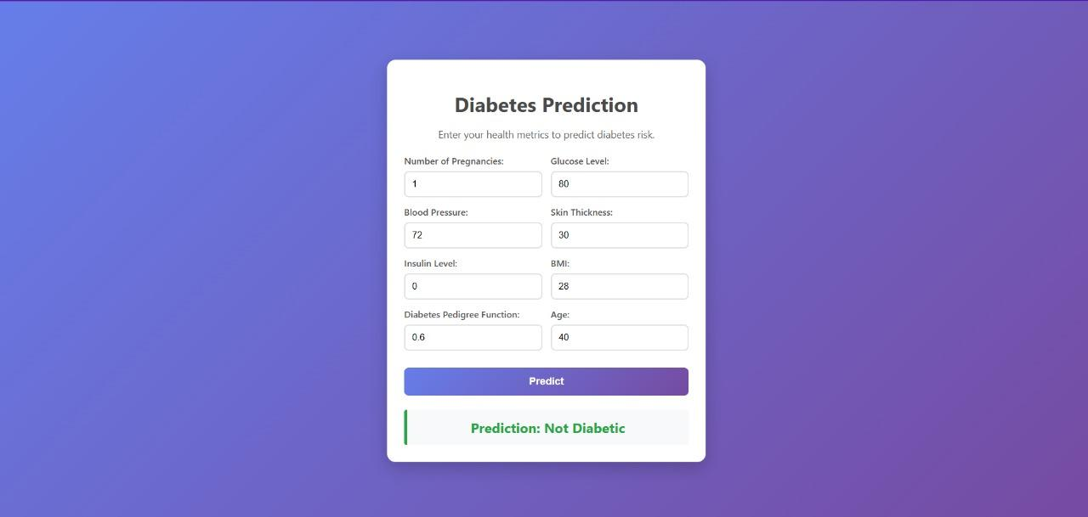

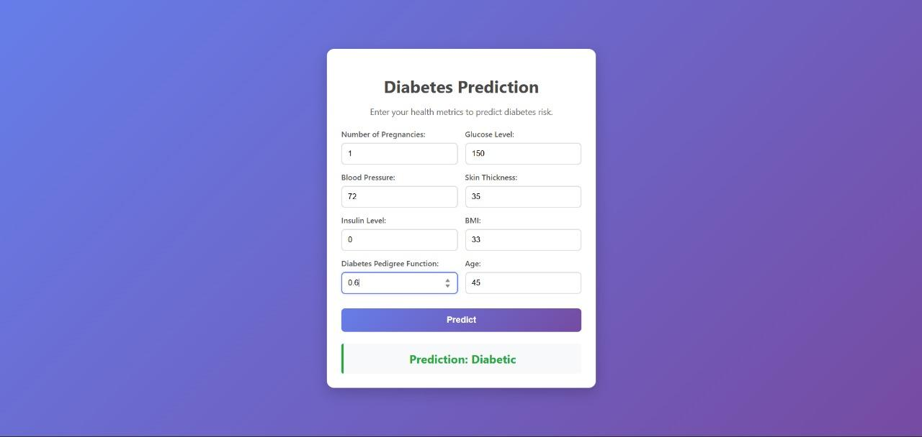

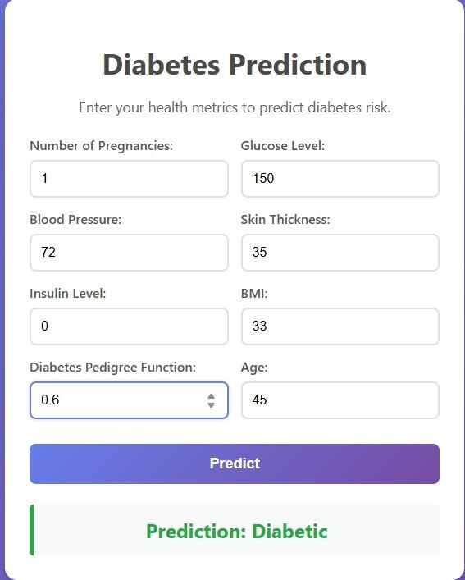

Conclusions
The model successfully predicts diabetes outcomes based on the given features. It is a useful tool for early risk assessment but should not replace medical diagnosis.

Future Scope
- Add more features for higher accuracy
- Deploy mobile app version
- Integrate with wearable medical devices

GitHub Link
Create a GitHub repository and upload your code, dataset, and documentation.
Link: _____________________________

